**EXPERIMENT NO -8**

**DEVOPS**

**AIM:** To understand Docker architecture and container life cycle, install Docker and execute Docker commands to manage images and interact with container.

**LO: 5** Explain concept of containerization and Analyze the Containerization of OS images and deployment of applications over Docker

**THEORY:**

Docker is an open-source centralized platform designed to create, deploy, and run applications. Docker uses container on the host's operating system to run applications. It allows applications to use the same Linux kernel as a system on the host computer, rather than creating a whole virtual operating system. Containers ensure that our application works in any environment like development, test, or production.

**Docker Containers**

Docker containers are the lightweight alternatives of the virtual machine. It allows developers to package up the application with all its libraries and dependencies, and ship it as a single package. The advantage of using a docker container is that you don't need to allocate any RAM and disk space for the applications. It automatically generates storage and space according to the application requirement.

**Advantages of Docker**

* There are the following advantages of Docker -
* It runs the container in seconds instead of minutes.
* It uses less memory.
* It provides lightweight virtualization.
* It does not a require full operating system to run applications.
* It uses application dependencies to reduce the risk.
* Docker allows you to use a remote repository to share your container with others.
* It provides continuous deployment and testing environment.

**Disadvantages of Docker**

* There are the following disadvantages of Docker -
* It increases complexity due to an additional layer.
* In Docker, it is difficult to manage large amount of containers.
* Some features such as container self -registration, containers self-inspects, copying files form host to the container, and more are missing in the Docker.
* Docker is not a good solution for applications that require rich graphical interface.
* Docker provides cross-platform compatibility means if an application is designed to run in a Docker container on Windows, then it can't run on Linux or vice versa.

**Docker Architecture:**

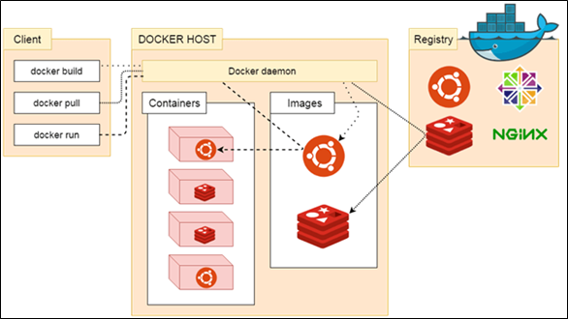

**OUTPUT:**

Step 1: Log into AWS account and launch an instance.

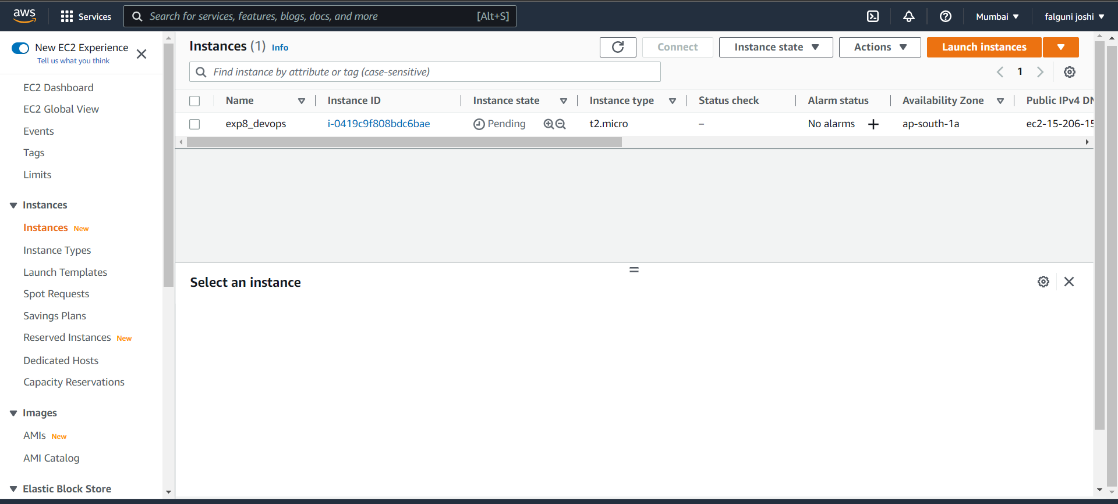

Step 2: Connect to puTTy.

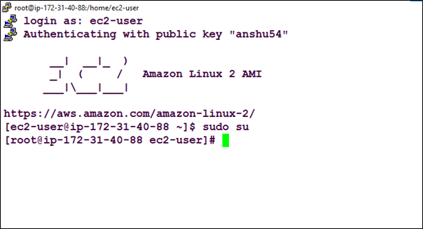

Step 3: Install Docker

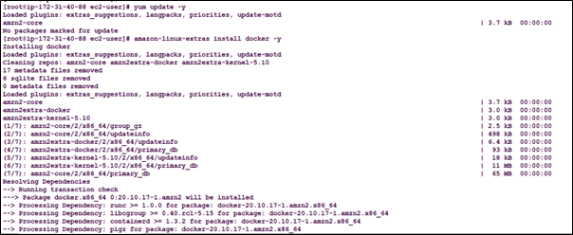

Step 4: Start the service of the docker



Step 5: Docker service status

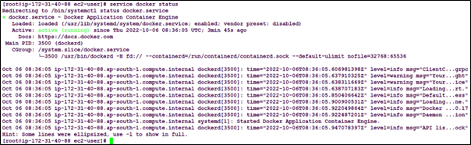

Step 6: Docker information

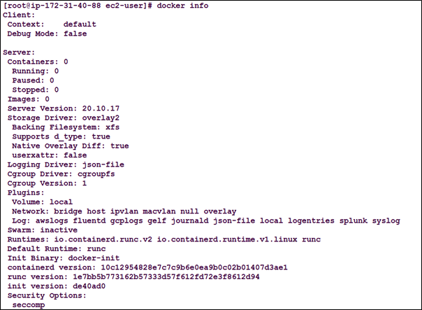

Step 7: Checking for the Docker images.

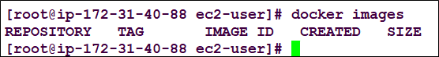

Step 8: Pulling from Ubuntu.

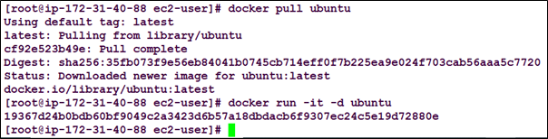

Step 9: Checking for the process

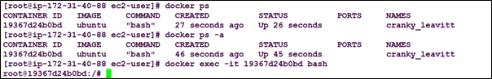

Step 10: Making directory demo

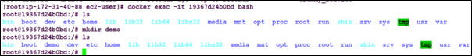

Step 11: Login into docker and creating images.

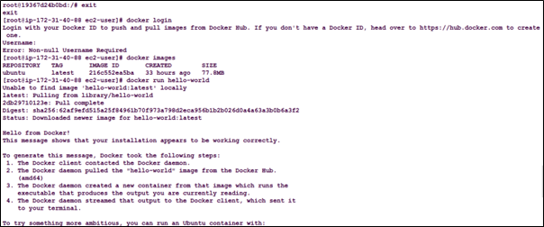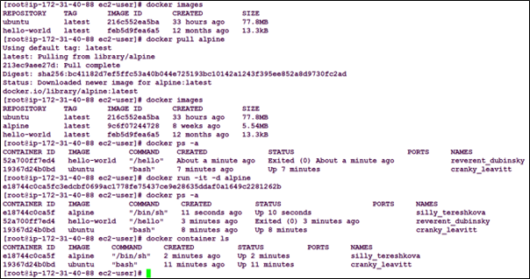

**CONCLUSION:**